Daniel Koniar
x500: konia013
ID: 4343456
CSCI 5551
Assignment #1
Problem #1
- Exercise 2.6
An order to derive the rotation matrix for a general axis (seen on pg. 47 in the textbook), we will first need to derive Rodrigues' rotation formula, which is:

To start, letbe some vector and letbe some arbitrary axis of rotation. An order to find the equation that will allow a to rotate aboutby some degreea few equations must be set up. First, we must get the projection ofon towhich can be done by the following equation:

Next, we will need to compute the perpendicular component to z aligned withwhich can be done with the following equation:

Lastly, we will need the orthogonal component toandwhich can be computed with the following:

Now, to explain the reason for using variablesis due to the fact that I set up the three previous equations to produce a frame whereis a projection onto the axis of rotation. By doing this, I can use the following equation to rotate the frame about the z-axis:

Now, usingI can compute thewhich is a rotated aboutbyTo do this, I can add the rotated x-component with my z-component to produce

I can now derive Rodrigues' rotation formula. The derivation can be seen below:

Now, we can use the Rodrigues' rotation formula to compute the rotation matrix for a general axis (seen on pg. 47 in the textbook). Since the book useswe will setin our equation as well as setAlso, we will use the books notation where andTo begin, we will set up Rodrigues' rotation formula with the new variables:

From the derivation above, we can see that through deriving and using Rodrigues' rotation formula, we can derive the the rotation matrix for a general axis, seen below:

- Exercise 2.11
The condition that would allow two rotation matrices representing finite rotations to commute is when the two rotations are about the same axis.

Problem #2
- Ifandare the coordinates of two points with respect to the reference coordinate system, determine the corresponding pointsandwith respect to the rotated OUVW coordinate system if it has been rotated 30 degrees about the OY axis.

- Ifandare the coordinates of two points with respect to the rotated OUVW, determine the corresponding pointsandwith respect to the reference coordinate system if it has been rotated 30 degrees about the OY axis.

Problem #3
- Exercise 3.2
Given that joint 3 has been converted into from a revolute joint to a prismatic joint, Figure 3.21 from the book was altered to portray the new link parameters for the modified PUMA 560:
1
2
3
4
5
6
Two changes have occurred due to the addition of a prismatic joint at joint 3:
  - One change can be noticed to table coordinate, which changed fromtoThis is because the joint atis now prismatic, so the joint can no longer rotate.
  - The next change is thatcan now vary in length. This actually does not alter anything in the table, nor for the final kinematic derivation.
Since change #1 has affected the final computation, only one link transformation matrix will alter (was computed using equation 3.6 from the textbook). For the sake of simplification, the textbook's notation will be adopted such that

The following notation will be used from this point on:

Problem #4
- Exercise 3.16
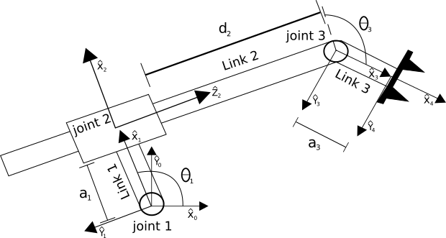
Note:

The figure on the previous page presents the link frames applied to the RPR planar robot that is shown in Figure 3.36 (pg. 97) in the book. The following table provides the linkage parameters for the figure above:

1
2
3
4

Also,aligns perpendicular to Link 2. This can be seen in anglein the diagram on the previous page.

- Exercise 3.17
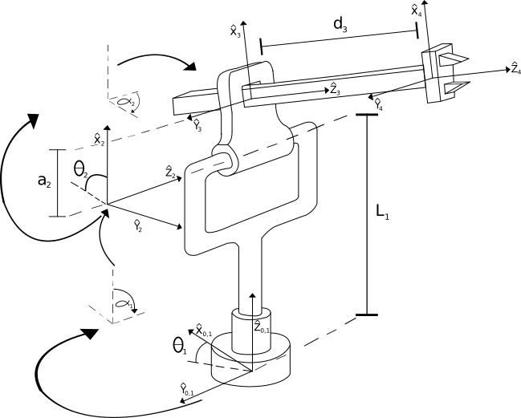
The figure above presents Figure 3.37 (pg. 97) from the book with the link frames listed.

